Rubric for Benchmark Review Project

 | 1 | 2 | 3 | 4 | Your Score
Content  x7 | Your project displays 5 or less standards or topics | Your project displays 6-9 standards or topics | Your project displays 10-13 standards or topics | Your project displays at least 14 standards or topics
Information  x4 | The topic provided is unclear and is missing vocab and formulas | The topic provided is clear but is missing academic vocab and/or formulas | The topic provided is clear but is missing academic vocabulary | The information provided about each topic is clear, using good vocabulary and formulas when necessary
Originality  x3 | Your idea is not unique and does not contain any creativity (white paper, pencil or pen, etc.) | Your idea is not unique and does not contain much creativity (bland, basic) | Your idea is not unique but contains creativity throughout | Your idea is either unique and contains elements of it that are creative and original
Depth  x7 | The content standards are not explained and lack proof of understanding | The content standards are somewhat explained and lack a clear understanding | The content standards are explained in detail but lack a clear understanding | The content standards are explained in detail and show a clear understanding of the standard
Neatness  x4 | The project is disorganized with many errors | The project is disorganized with few errors | The project is organized but has few errors | The project is organized, neat, and free of errors
Your Total Score is a sum of the parts from this rubric /100
Follow the rubric outlined below to create a project that demonstrates standards that we need to remember and others that we still need to learn. You are free to use your creativity in how you present your information, as long as it follows the requirements of the rubric.

You may want to do something like…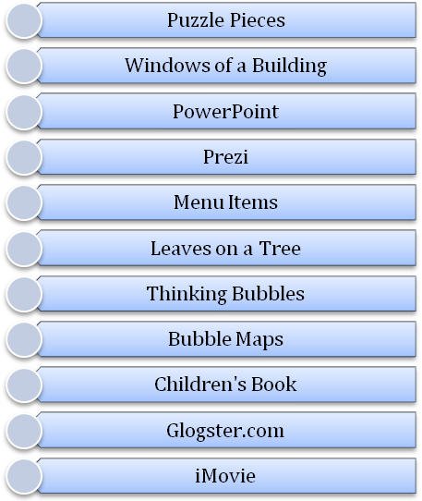

But avoid something like…

